Problem brief

A customer has asked you to create a telephone directory application using Python or any other relevant programming language.

The application is command prompt and menu driven. The application should cater for the following requirements:

* Each data entry represents a list of contacts with details such as first name, last name, age, sex, telephone number and address for each individual contact
* The data is to be stored permanently using either a file or database.
* The application should have the following utilities:
  + Display all contacts and all of their relevant details
  + Search by name (by entering one or more characters) displaying all contacts that fit the search
  + Search by telephone number (by entering one or numbers) displaying all contacts the fit the search
  + Add a new contact
  + Remove a contact (using name and or telephone number)
* When exiting the contact list should be written back to the file or database

The application should be secure allowing only those with specific password to access the application. The program should be user friendly and error free.

The customer would like to know how long the project will take to complete and how much will cost.

PS: The customer does not have a lot of cash to spend!!!!!.

**Task 1**

Provide a Requirement Specifications document, it must include:

* Application name,
* problem Brief
* Application type,
* Application purpose (what it will do) and the target audience,
* List of functional and non-functional Requirements

**Application name:** Phonebook

**Application Type:** Telephone Directory

**Problem Brief:**

To create a telephone directory application using Python or any other relevant programming language.

The application is command prompt and menu driven. The application should cater for the following requirements:

* Each data entry represents a list of contacts with details such as first name, last name, age, sex, telephone number and address for each individual contact
* The data is to be stored permanently using either a file or database.
* The application should have the following utilities:
  + Display all contacts and all of their relevant details
  + Search by name (by entering one or more characters) displaying all contacts that fit the search
  + Search by telephone number (by entering one or numbers) displaying all contacts the fit the search
  + Add a new contact
  + Remove a contact (using name and or telephone number)
* When exiting the contact list should be written back to the file or database

The application should be secure allowing only those with specific password to access the application. The program should be user friendly and error free.

The customer would like to know how long the project will take to complete and how much will cost.

PS: The customer does not have a lot of cash to spend!!!!!.

**Application Purpose:**

Each data entry represents a list of contacts with details such as first name, last name, age, sex, telephone number and address for each individual contact   
- The data is to be stored permanently using either a file or database.    
- The application should have the following utilities:    
 - Display all contacts and all of their relevant details    
 - Search by name (by entering one or more characters) displaying all contacts that fit the search    
 - Search by telephone number (by entering one or numbers) displaying all contacts the fit the search    
 - Add a new contact    
 - Remove a contact (using name and or telephone number)    
- When exiting the contact list should be written back to the file or database, if the user confirms

The application should be secure allowing only those with specific password to access the application.

**Target Audience:** Any person with the password access granted: from children to older people.

**Functional Requirements:**

0.Telephone Directory

1. List of all entries

2. Search the Directory by Name

3. Search the Directory by Number

4. Add new contact(s)

5. Remove contact (using name and or telephone number)

6. Save (if confirmed) and EXIT

**Non-Functional Requirements:**

1. Password protected.
2. User friendly

**Task 2**

Action plan detailing key tasks and milestones with realistic timescales attached to them.

**Task 3**

List of resources required including physical hardware, software and electronic media. It must include the development environment selected (i.e. planning, design and development environment. It should be noted that the development environment must include some form of structured programming and at a minimum should contain variables, selection based on logical conditions, loops and functions.

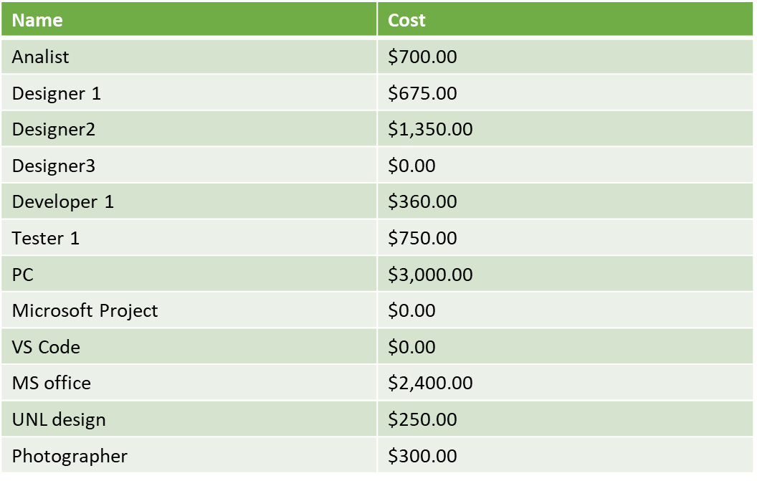

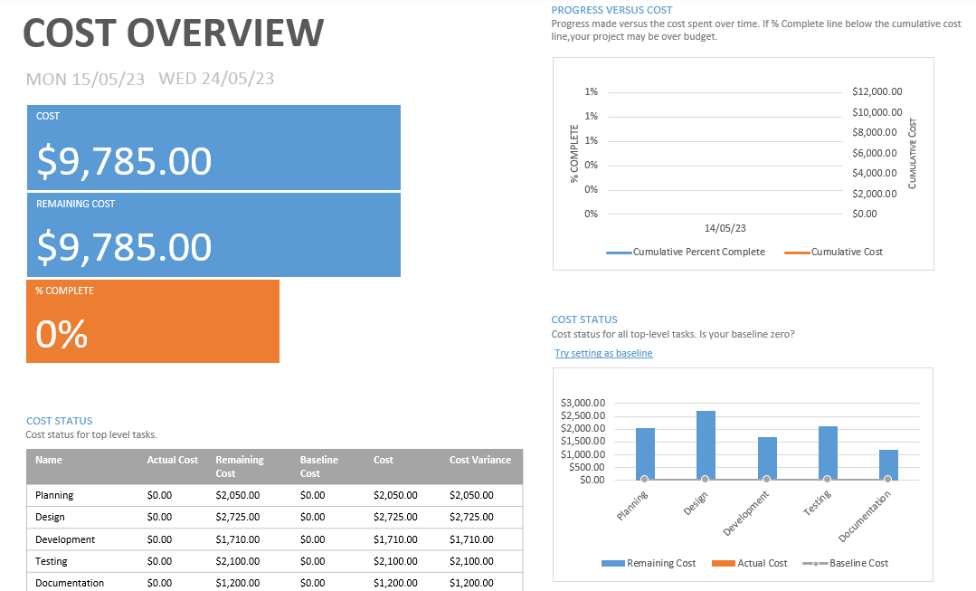

**Task 4 - Design**

* **Design diagrams (structure charts)**

* **Data Dictionary**

We will create the data lists to be filled the details from the file:

names=[]

surnames=[]

ages=[]

sexes=[]

phones=[]

addresses=[]

The functions to be executed:

main()

password(names,surnames,ages,sexes,phones,addresses)

readData(names,surnames,ages,sexes,phones,addresses)

menu(names,surnames,ages,sexes,phones,addresses)

printer(names,surnames,ages,sexes,phones,addresses)

searchByName(names, surnames,ages,sexes,phones,addresses)

searchByNumber(names, surnames,ages,sexes,phones,addresses)

addContact(names,surnames,ages,sexes,phones,addresses)

removeContact(names, surnames, ages, sexes, phones, addresses)

exportData(names,surnames,ages,sexes,phones,addresses)

exit(0)

* **Pseudocode**

1. Declare variables: names,surnames,ages,sexes,phones,addresses   
2. Run the Main => password, prompt the user to enter password.

3. If password is not correct ->return for 2nd and 3rd attempt. If not correct =>exit

If password is OK =>run Read function, split and append the Details to their lists

4. open the MENU (loop while TRUE) and prompt the user to make a choice (1-6)

5. if 1 =>open PRINTER:

Print i in range len(names)

6. if 2 => open SearchByName

Run bool loop

Prompt the user to enter letter(s)

If name/surname contains letters:

print the details for found & number of coins=coincidences

else:

print The name is not found

7. if 3 => open SearchByNumber

Run bool loop

Prompt the user to enter digits(s)

If phone number contains digits:

print the details for found & number of coins=coincidences

else:

print The number is not found

8. if 4 => open addContact

Prompt the User to enter the number of contacts to add

Prompt the User to enter the NAME of contacts to add

Prompt the User to enter the SURNAME of contacts to add

Prompt the User to enter the SEX of contacts to add

Prompt the User to enter the PHONE of contacts to add

Prompt the User to enter the ADDRESS of contacts to add

Append the Details

9. if 5 => open RemoveContact

If len(names)=0:

print: The list is emty. Nothing to delete.

Else:

prompt the user to enter the name to delete

if name in the list: print the entry details and ask user to confirm removal

if confirmed: delete all the details for the entry

else: inform the user that removal is cancelled

else: info the user that there is NO such entry

10. if 6 => ask the user if he wants to save changes

If yes => open Export

write the details

Else =>EXIT without saving

* **Test Cases form:**

